Project Title: Email & Report Automation System
Domain: Python Automation
Intern Name: T.Vaishnavi
Email : vaishnavithanda49@gmail.com
Submission Date: May 16, 2026

1. Project Overview & Objective
In many business environments, professionals spend hours daily opening raw data sheets, calculating totals, creating charts, and manually emailing reports to stakeholders.
The objective of this project is to build a robust, production-ready Data Pipeline Automation System using Python. The system completely eliminates manual intervention by reading a raw data source, processing the metrics, generating both an Excel sheet and a visual chart, and securely distributing them via email on a daily schedule.

2. Tools & Technologies Used
- Language: Python 3.10+
- Data Processing: Pandas (for structuring and aggregating raw records)
- Visualization: Matplotlib (for creating the analytical bar chart)
- Excel Generation: Openpyxl (integrated with Pandas to output .xlsx files)
- Email Protocols: SMTPLIB & EmailMessage (for managing secure SMTP transport layer connections via SSL port 465)
- System Monitoring: Datetime & Time (for background time loops and system logging)

3. System Architecture & Methodology
The script is designed as an architectural pipeline that moves data through four distinct phases:
[Raw CSV Data] ➔ [Pandas Processor] ➔ [Excel/Chart Generators] ➔ [SMTP Distribution]
- Phase 1: Data Processing & Summary Generation: The system reads the raw data.csv sheet using Pandas. It applies data aggregation (groupby) to isolate product categories and compute total sales metrics.
- Phase 2: Excel Report Production: The aggregated metrics are exported into a clean, formatted Excel file (Sales_Summary_Report.xlsx) utilizing the openpyxl engine.
- Phase 3: Visualization: Matplotlib processes the summarized matrix to render a styled bar chart (report_chart.png) detailing categorical sales performance with custom labeling and formatting.
- Phase 4: Automated SMTP Distribution & Scheduling: The script maintains an active background listening loop using time.sleep(). When the computer clock matches the target deployment window, the script authenticates with Gmail's SMTP servers using a secure 16-character App Password, bundles both the Excel file and chart as attachments, transfers the email payload, and records the outcome to an external automation_log.txt ledger.

4. Source Code
import pandas as pd
import matplotlib.pyplot as plt
import smtplib
from email.message import EmailMessage
import datetime

# 1. LOAD THE DATA
# Make sure 'data.csv' is in the same folder as this script
df = pd.read_csv('data.csv')

# 2. GENERATE THE SUMMARY
summary = df.groupby('Category')['Sales'].sum()
print("Report Summary:")
print(summary)

# 3. CREATE A BAR CHART
summary.plot(kind='bar', color='skyblue', edgecolor='black')
plt.title('Total Sales by Category')
plt.xlabel('Category')
plt.ylabel('Sales ($)')

# 4. SAVE THE CHART IMAGE
plt.tight_layout()
plt.savefig('report_chart.png')
print("Chart saved as report_chart.png")

# Note: plt.show() is removed so the script sends the email automatically
# without waiting for you to close a window.

# --- EMAIL CONFIGURATION ---
sender_email = "vaishnavithanda49@gmail.com"
app_password = "pszt gafx ybct zdqh"
recipient_email = "vaishnavithanda49@gmail.com" # Fixed the spelling typo here

# Create the email container
msg = EmailMessage()
msg['Subject'] = 'Daily Sales Automation Report'
msg['From'] = sender_email
msg['To'] = recipient_email
msg.set_content("Hello,\n\nPlease find the automated sales report chart attached.\n\nBest regards,\nPython Automation Bot")

# --- ATTACH THE CHART ---
with open('report_chart.png', 'rb') as f:
file_data = f.read()
msg.add_attachment(file_data, maintype='image', subtype='png', filename='Sales_Report.png')

# --- SEND THE EMAIL & LOG THE RESULT ---
try:
print("Connecting to server...")
with smtplib.SMTP_SSL('smtp.gmail.com', 465) as smtp:
smtp.login(sender_email, app_password)
smtp.send_message(msg)

print("✅ Email sent successfully!")

# LOG THE SUCCESS
with open("automation_log.txt", "a") as log:
timestamp = datetime.datetime.now().strftime("%Y-%m-%d %H:%M:%S")
log.write(f"[{timestamp}] SUCCESS: Report sent to {recipient_email}\n")

except Exception as e:
# LOG THE ERROR
with open("automation_log.txt", "a") as log:
timestamp = datetime.datetime.now().strftime("%Y-%m-%d %H:%M:%S")
log.write(f"[{timestamp}] ERROR: {str(e)}\n")
print(f"❌ Error: {e}")

5. Visual Evidence & Results (Screenshots)

A. Development Environment
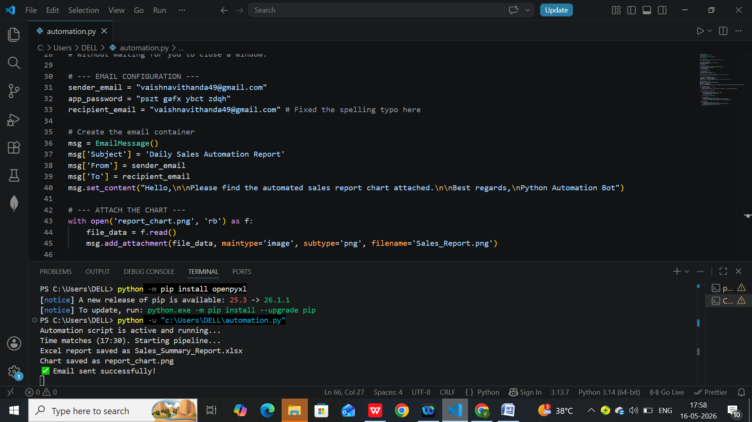

B. Output Artifacts: Generated Sales Chart
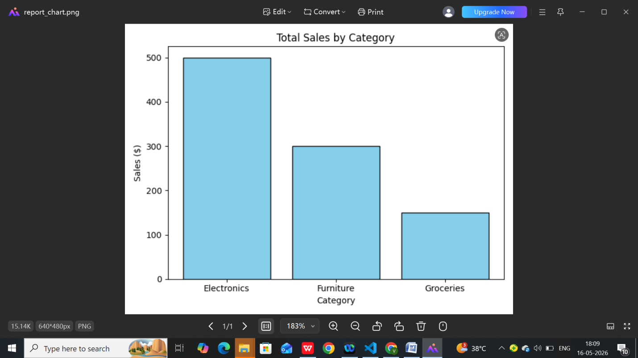

C. Output Artifacts: Generated Excel Workbook
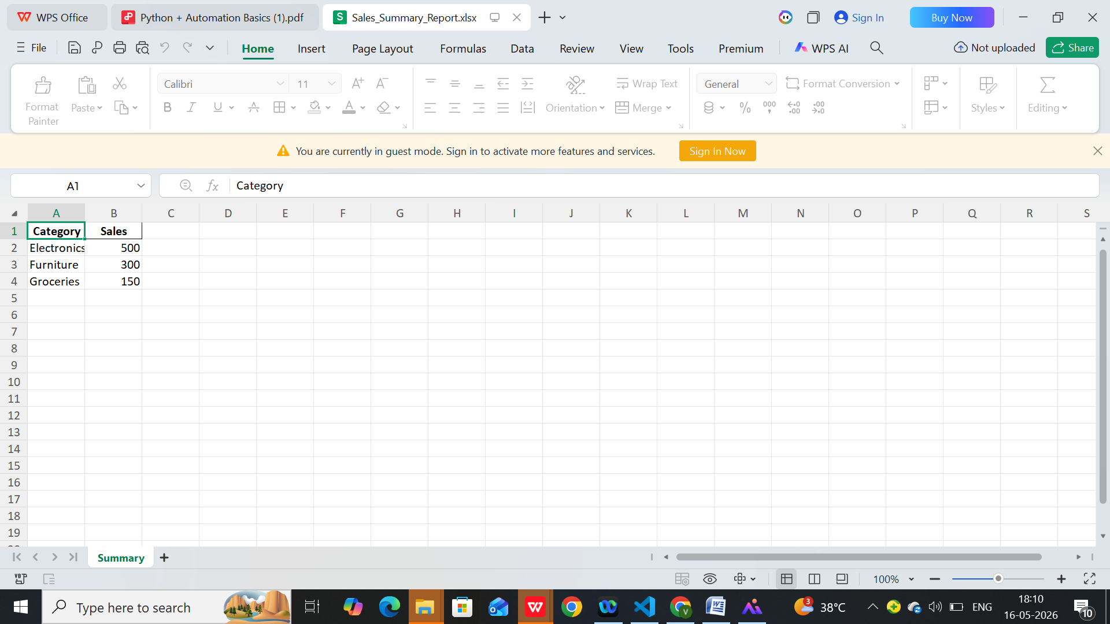

D. System Activity Log (automation_log.txt)
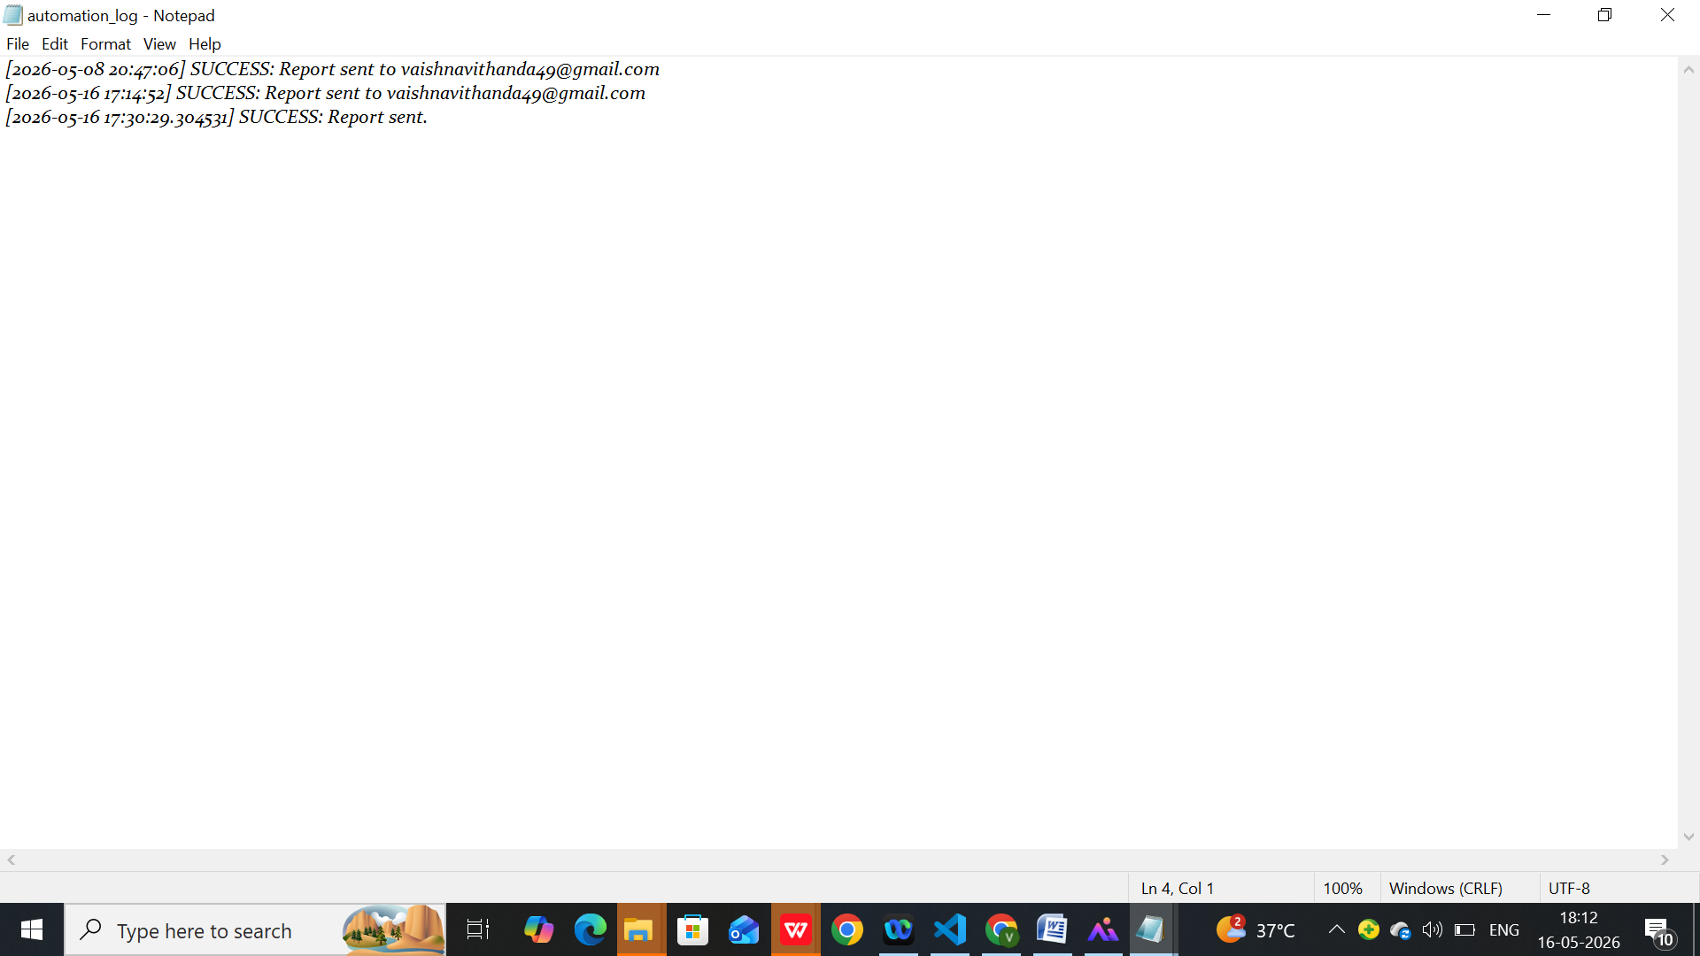

E. Proof of Delivery (Gmail Inbox)
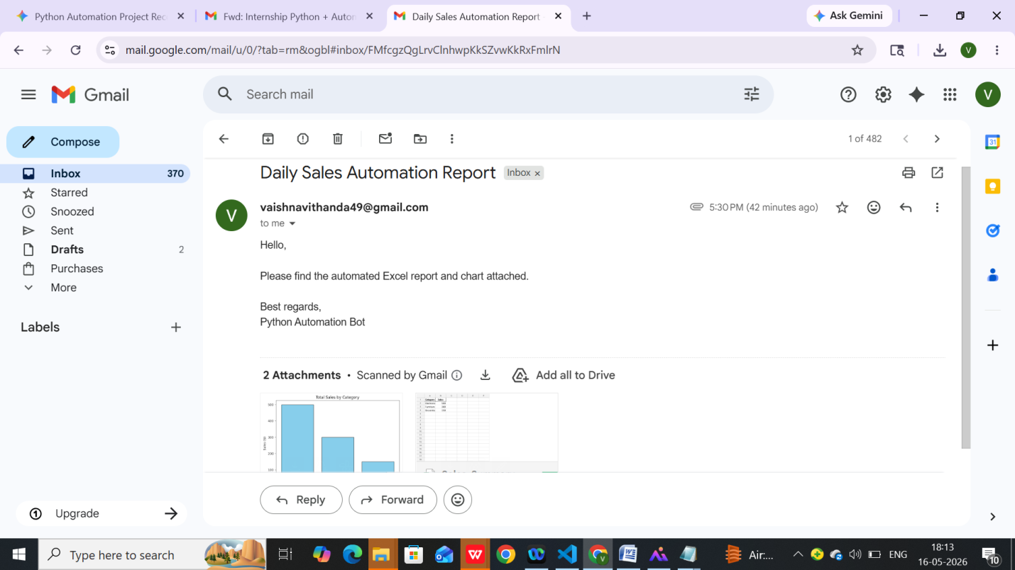

6. Scope for Future Enhancements
While the core automation pipeline is fully operational, future production upgrades could include:
- Database Integration: Migrating from static CSV files to live SQL database connections for real-time tracking.
- Dynamic HTML Email Bodies: Upgrading the email layout from standard plain text to structured HTML tables so the summary metrics are displayed inline inside the email reader.
- Cloud Deployment: Moving the local script to a cloud server (like AWS or Google Cloud Functions) so it can run 24/7 without needing a local laptop to stay powered on.

